Assembly instructions for

Speeduino v0.4.3

Compatible M52 PnP ecu

1. Disassemble the original ms41 ecu 2

2. Assemble the PCB 6

3. Modifying the ms41 case for new PCB 8

4. Final assembly 10

5. Testing the Assembled ecu 11

# Disassemble the original ms41 ecu

Open the 4 screws in the top of the case and 4 screws at the bottom of the case to remove the covers:

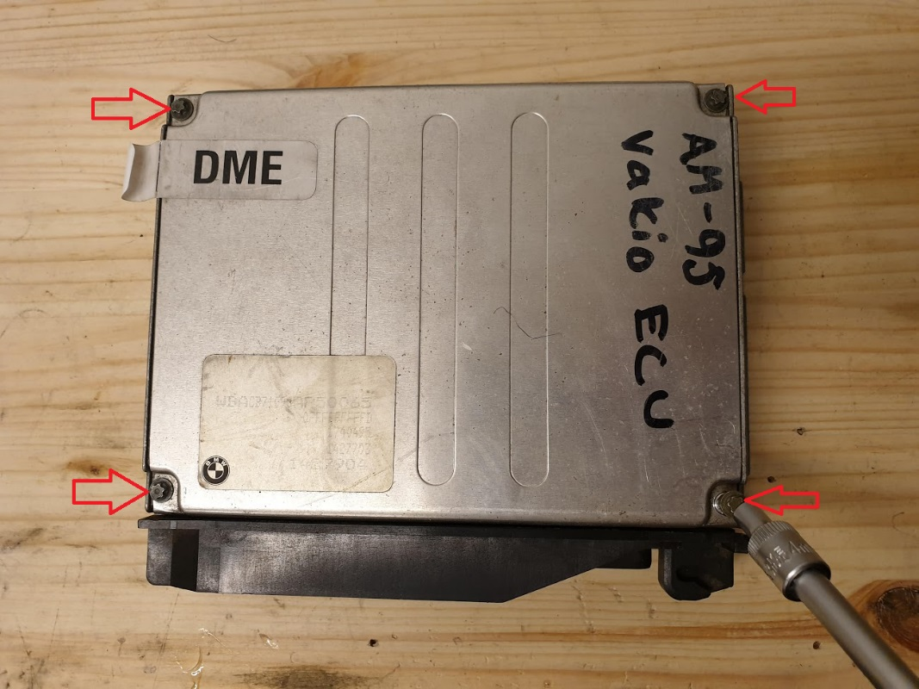

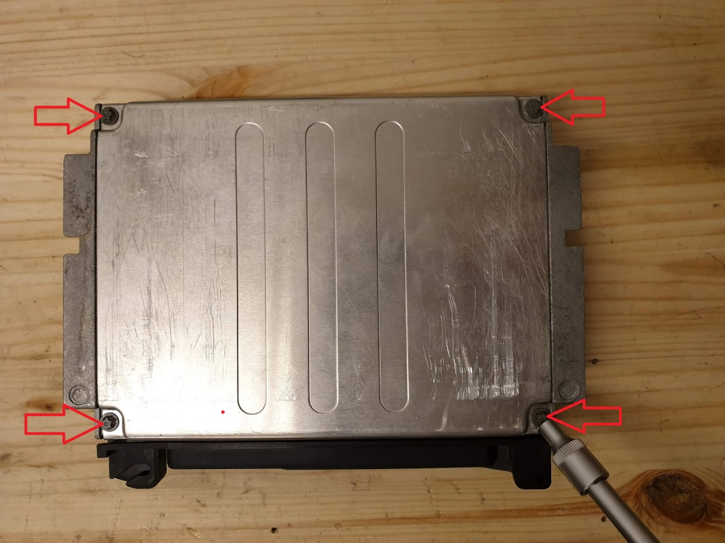

The screws are E-torx type, but regular 4mm socket can be used too.

After removing the top and bottom covers, open the 4 screws holding the PCB:

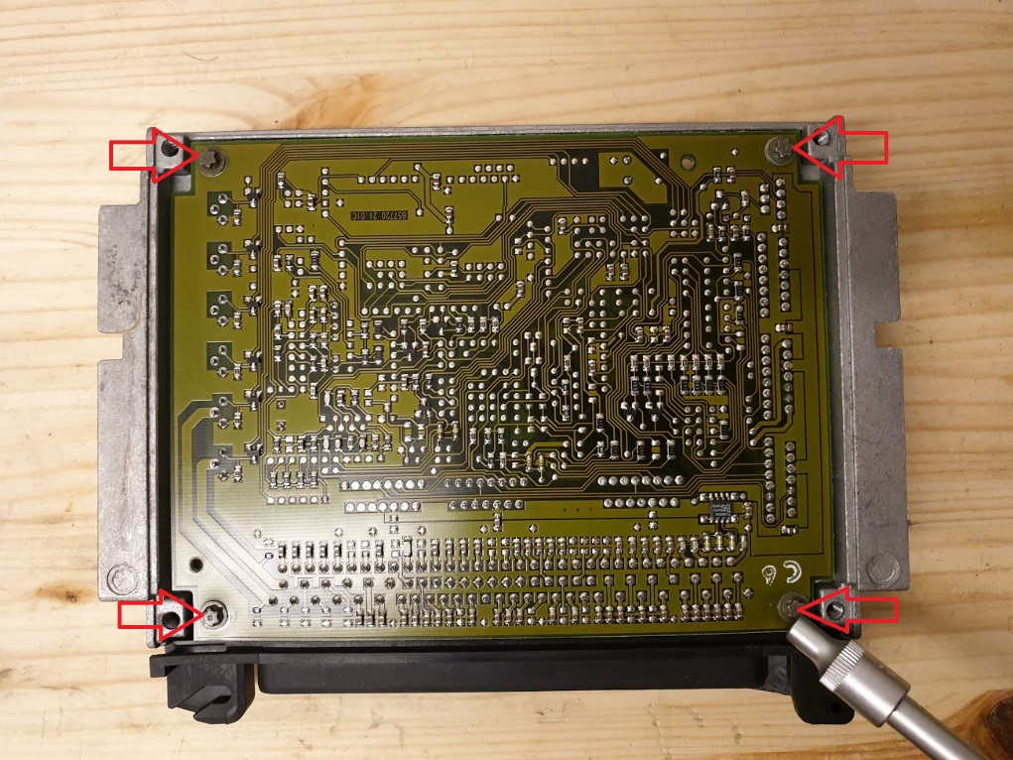

Pop-off the metal clamps that hold the power components against the case and remove the plastic covers too:

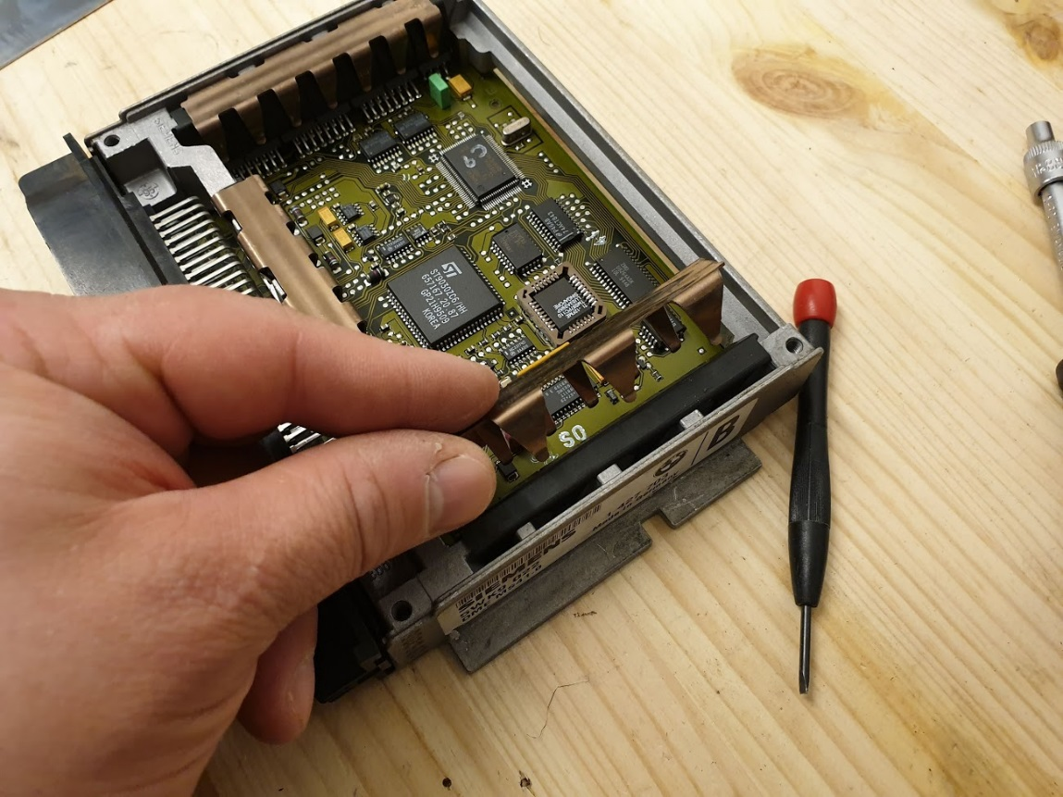

The 6 ignition drivers might be stuck to the thermal conductive sheet, but after popping those free the original PCB should come off the case:

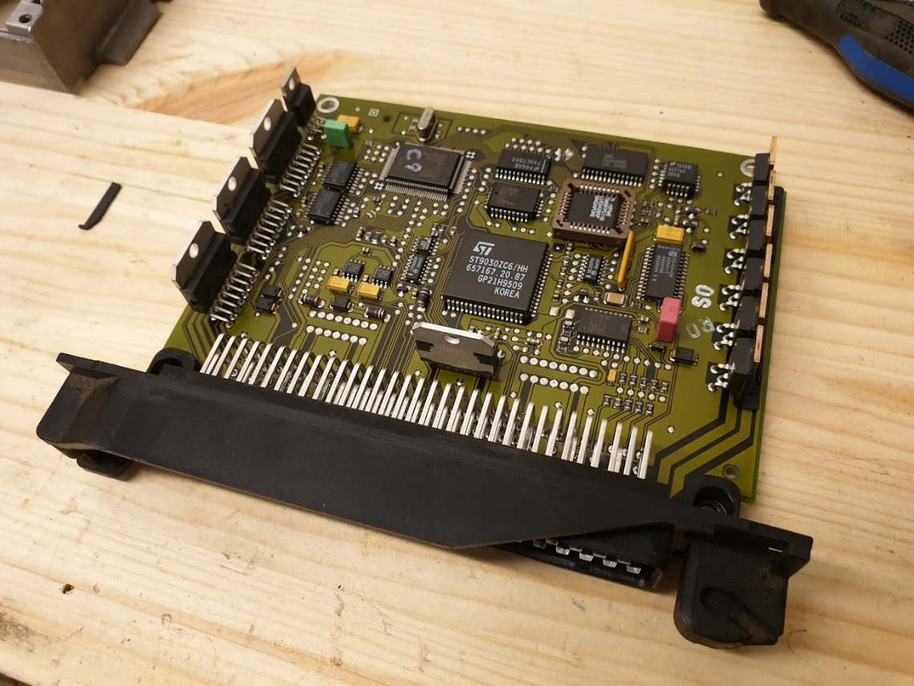

De-solder the big 88-pin connector from the PCB using solder wick or solder vacuum:

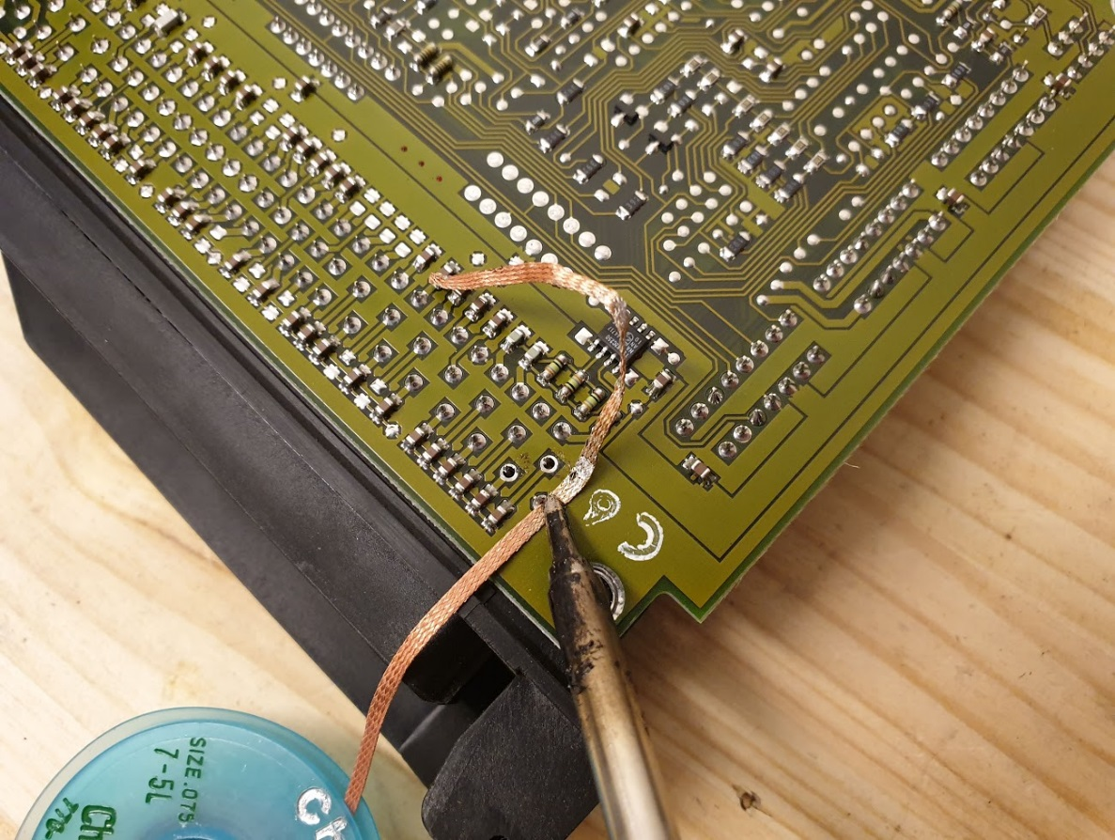

Or use brute-force method and fry the whole PCB using heat gun to free up the connector:

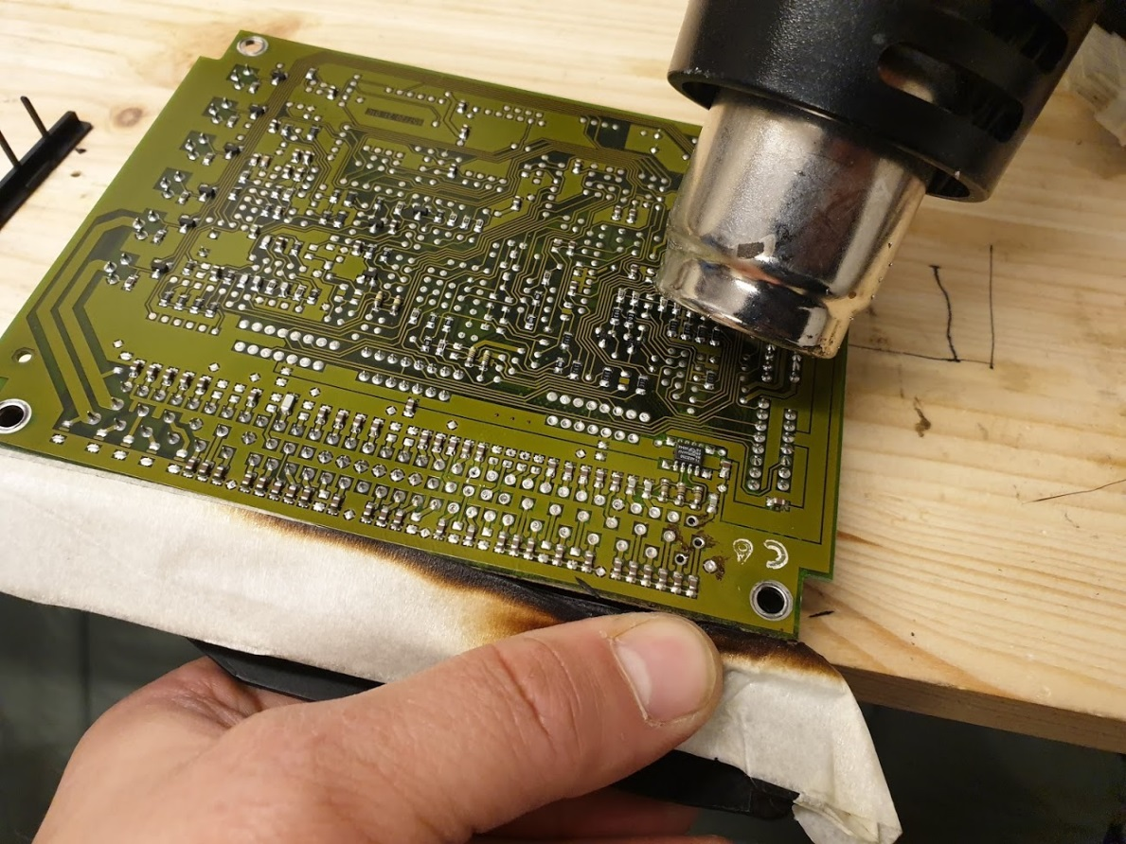

Be careful not to melt the connector housing while doing this. And use for example welding gloves to protect your hands from the heat.

After de-soldering the 88-pin connector, place it to the case to wait for next step and clean up the remaining solder from the pins:

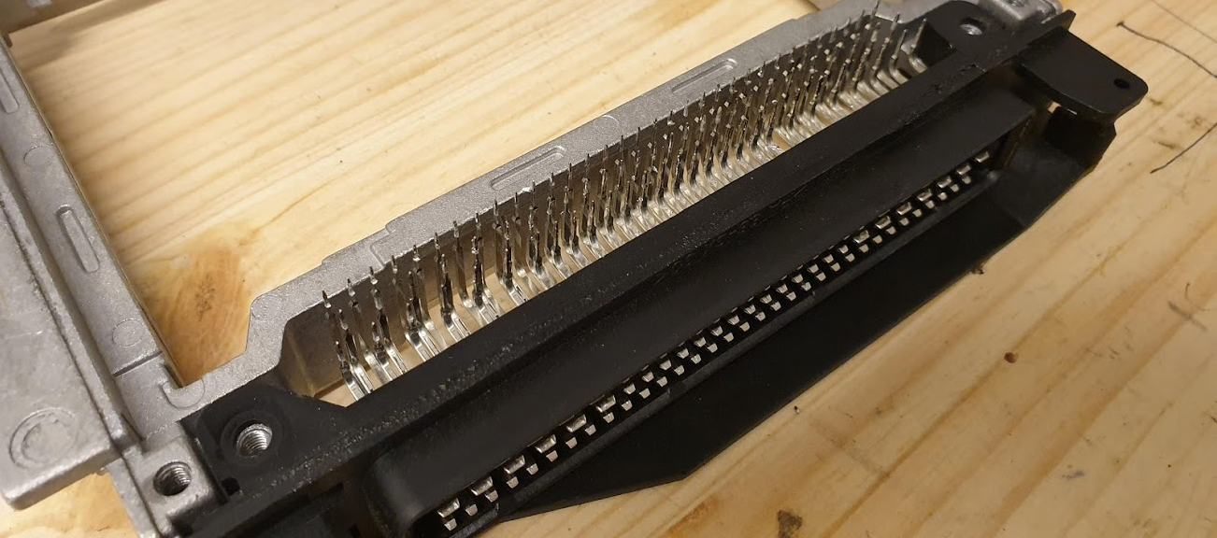

# Assemble the PCB

To assemble the PCB, you need to have the components listed in the BOM. BOM’s for different PCB revisions can be found from here: https://github.com/pazi88/Speeduino-M5x-PCBs/tree/master/m52%20PnP

Solder the components to the PCB according to the labels on the board. Be careful to match the component types and values to what is in the BOM. The order where the components are soldered, doesn’t really matter. But for ease of assembly this order is recommended:

1. All resistors
2. All diodes (Including LEDS)
3. All capacitors
4. Arduino pins:

Suggested method: Break header pins into required lengths and insert into an Arduino Mega. Place the board over the top of the pins and solder in place

1. ICs
2. All MOSFETs and IGBT’s
3. Power regulator
4. Bluetooth pin headers

Note the orientation of these component types:

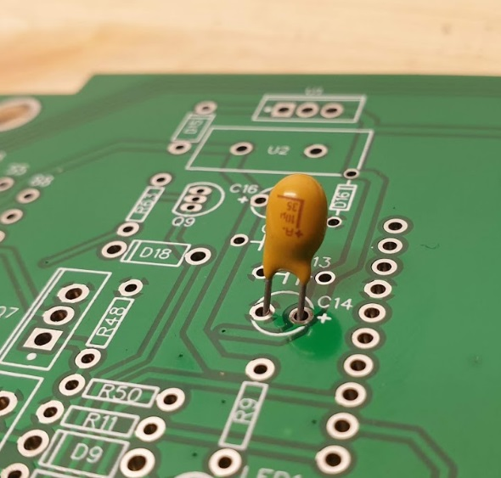 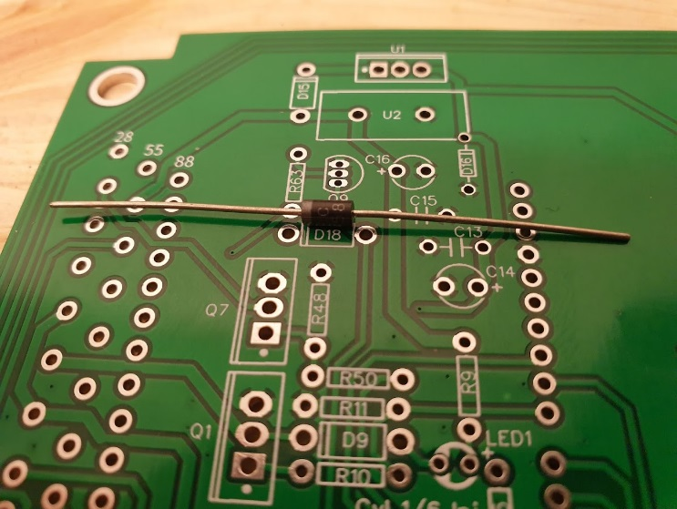

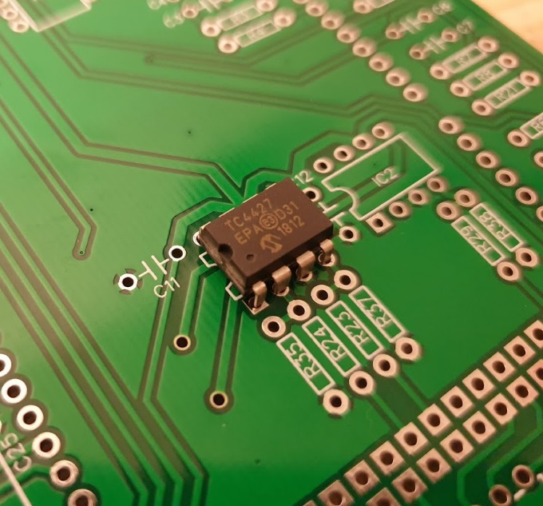 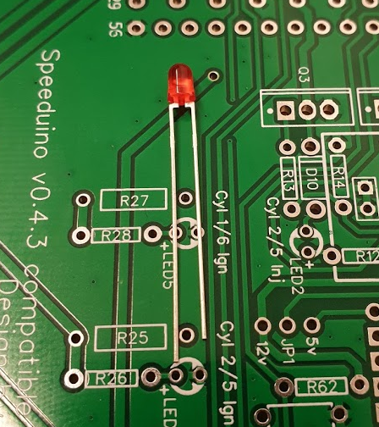

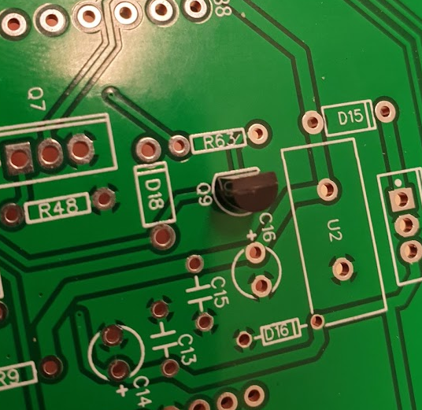 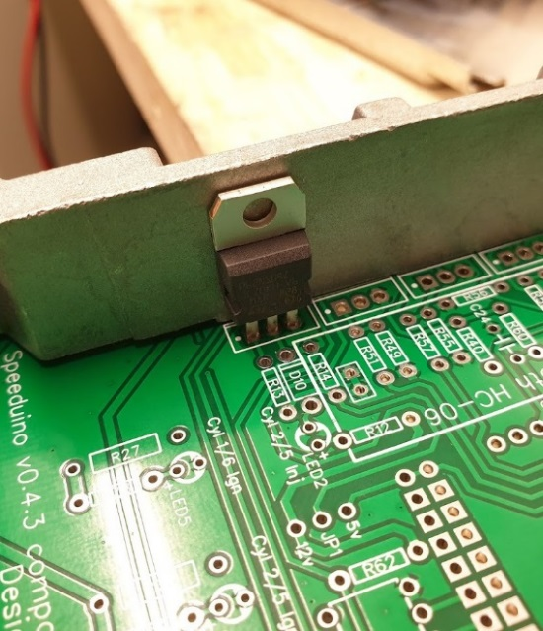

# Modifying the ms41 case for new PCB

Before soldering in the MAP sensor and external header, it’s recommended to screw in the PCB to the ms41 case that has the 88-pin connector and solder the 88-pin connector to the PCB.

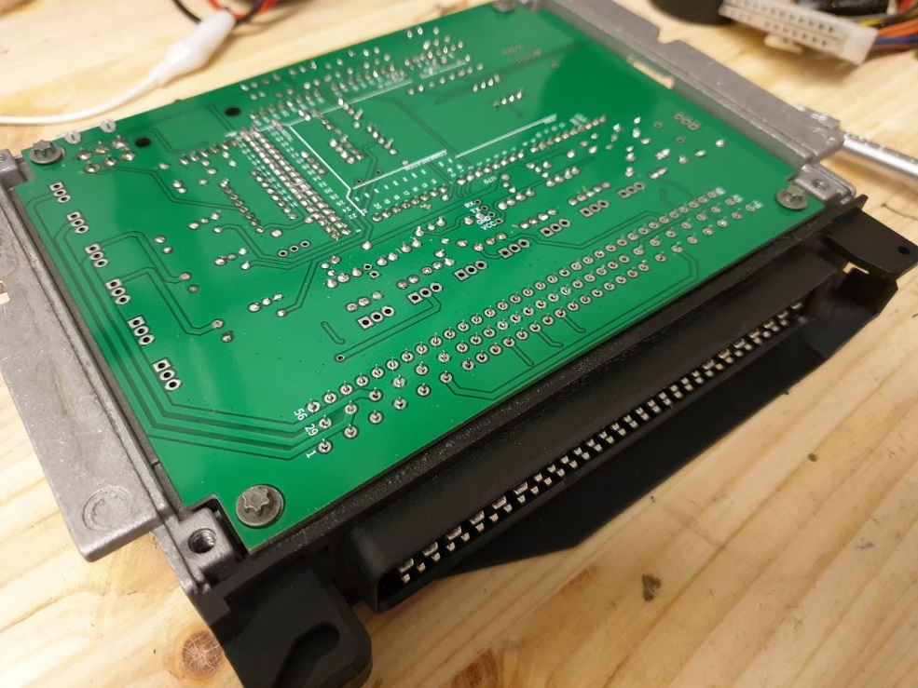

After soldering in the 88-pin connector, take the PCB out of the case, pop in the Arduino mega and solder in the MAP sensor and external connector:

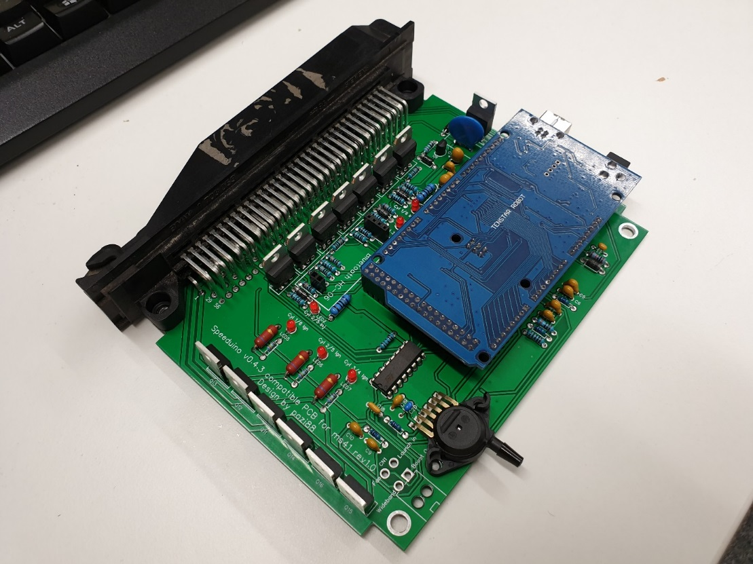

Now use the PCB assembly as a guide to cut notches to the case for the Arduino Mega, MAP sensor and external connector. Needed cuts for rev 1.0/1.1 PCB:

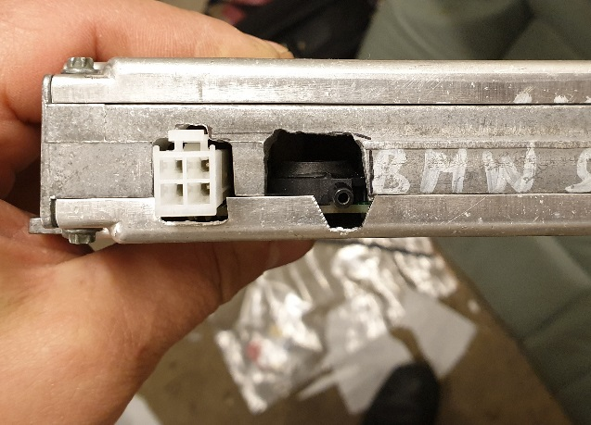 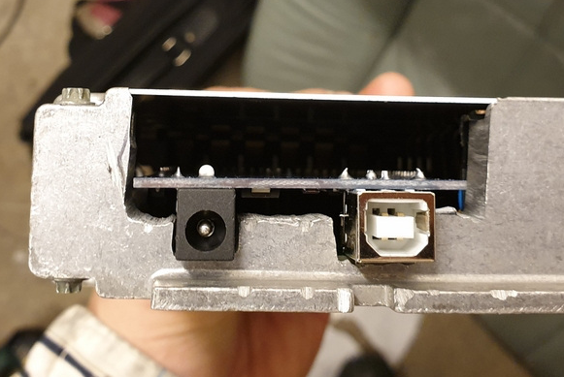

In rev 1.2, there is no need to cut hole for whole Mega. Just for the USB connector, if the unused DC jack is removed:

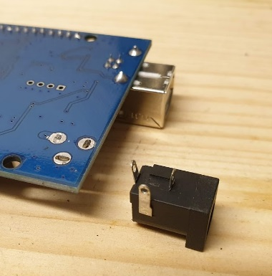 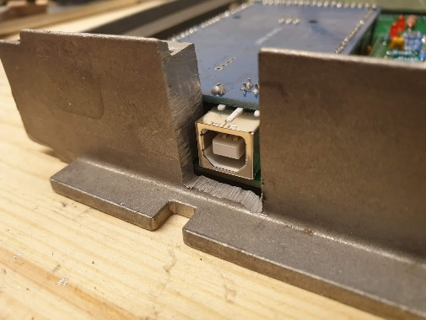 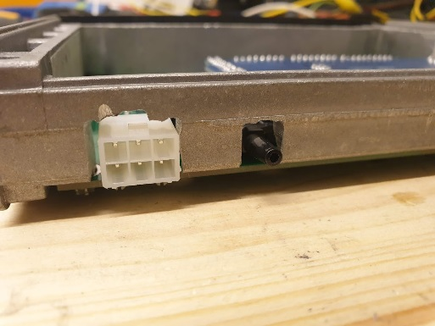

Make sure that the cuts/holes are at correct location by test fitting the PCB and then apply the adhesive insulation pads so that the power components with TO220 cases don’t touch the ms41 case. Bigger insulation sheets can also be used for ease of assembly, but these are not in BOM:

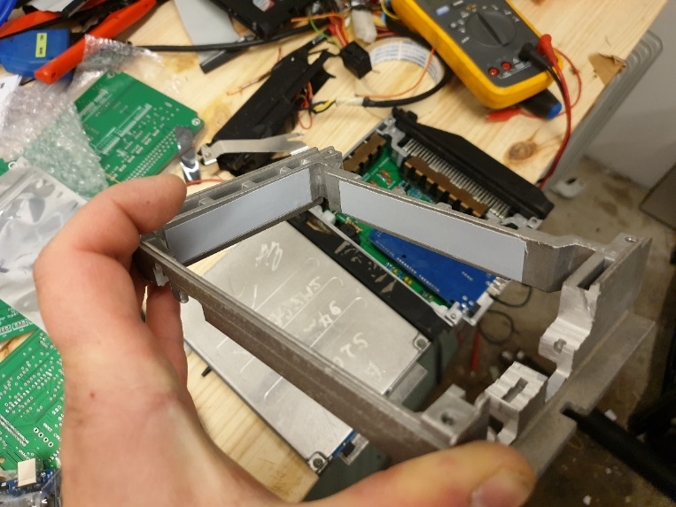

# Final assembly

Screw in the assembled PCB to the ms41 case and use the metallic clamps with the plastic parts under to secure the components with TO220 case to the ms41:

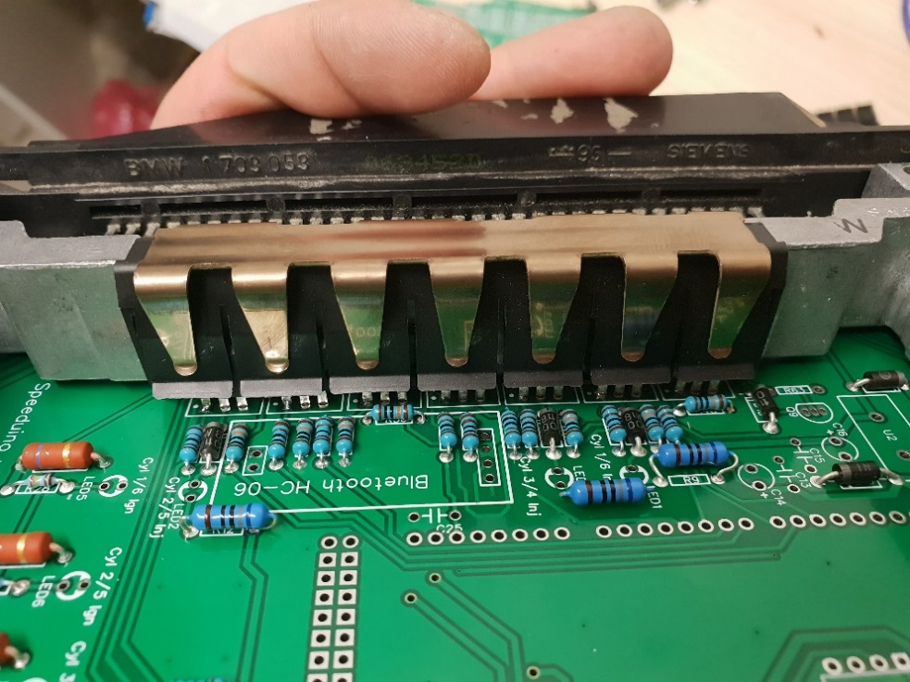

While doing that, make sure that the insulation pads are at the right spot, so that the components don’t touch the ms41 casing. The metal clamp and plastic cover for power regulator needs to be cut in order to fit it. Lastly pop in the Arduino mega and use m4 nylon screws or zip-ties to secure the MAP sensor to the PCB and the assembly is almost done:

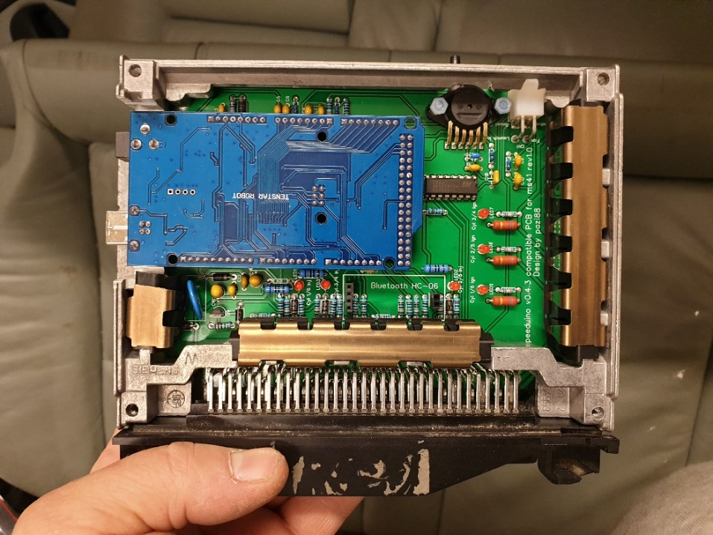

# Testing the Assembled ecu

Before finishing up the ecu, it’s good to test that it works. Load in the Firmware using Speedyloader: <https://speeduino.com/wiki/index.php/Compiling_and_Installing_Firmware> and load in the M52 base tune available at Google drive folder. After loading in the M52 base tune, power cycle the ecu and make sure that the ignition leds do not light up. If they do, something has gone wrong and issue needs to be fixed. DO NOT PLUG IN THE ECU IN THE CAR, BEFORE THE BASE TUNE IS LOADED AND YOU HAVE CHECKED THAT THE LEDS ARE NOT LIT. Calibrate the temperature sensors using the calibration values available at the Google drive folder and after that, the ecu can be plugged into the car.

Turn on the ignition and check that the IAT and coolant temp sensors show reasonable temperatures. Also make sure that the voltage sensing shows correct voltage and map sensor shows about 100kpa values. If everything is normal, the top and bottom covers can be screwed in and do the normal configuration for the ecu to match it your setup. Also remember to put back in the plastic sheet that goes between the bottom cover and the PCB.

|  |  |  |  |  |  |  |
| --- | --- | --- | --- | --- | --- | --- |
| **QTY Full** | **Board Reference Full** | **Value** | **Type** | **Information** | **Manufacturer** | **Model#** |
|  |  |  |  |  |  |  |
| 1 | C16 | 10uF | CAP TANT 10UF 35V 10% RADIAL | Tantalum | Kemet | T356G106K035AT |
| 5 | C2,C4,C6,C8,C10 | 0.22uF | CAP CER 0.22UF 50V 10% RADIAL | X7R | Kemet | K224K20X7RF5UH5 |
| 7 | C1,C3,C5,C7,C9,C13,C15 | 0.1uF / 100nF | CAP CER 0.1UF 50V 20% RADIAL | X7R | Kemet | C322C104M5R5TA7301 |
| 1 | C14 | 47uF | CAP TANT 47UF 6.3V 10% RADIAL | Tantalum | Kemet | T356F476K006AT |
| 2 | C18,C26 | 0.33uF | CAP CER 0.33UF 50V 10% RADIAL | X7R | AVX Corporation | AR215F334K4R |
| 3 | C19,C24,C27 | 0.01uF | CAP CER 10000PF 50V 10% RADIAL | X7R | Kemet | C317C103K5R5TA |
| 4 | C11,C12,C20,C28 | 1uF | CAP CER 1UF 50V 20% RADIAL | X7R | Kemet | C330C105M5U5TA |
| 2 | C23,C25 | 4.7nF | CAP CER 4700PF 100V 10% RADIAL | X7R | Kemet | C317C472K1R5TA |
|  |  |  |  |  |  |  |
| 1 | D16 | 1N5919BG Zener | DIODE ZENER 5.6V 3W AXIAL | DO-41 | ON Semiconductor | 1N5919BG |
| 2 | D15,D17 | 1N5818-TP Schottky | DIODE SCHOTTKY 1A 30V DO41 | DO-41 | Micro Commercial Co | 1N5818-TP |
| 6 | LED1,LED2,LED3,LED5,LED6,LED7 | LED-Red | LED SS 3MM 625NM RED DIFF | 5mm-LED |  | LTL-4221N |
| 4 | D9,D10,D11,D18 | 1N4004 | DIODE GEN PURPOSE 400V 1A DO41 | DO-41 | Micro Commercial Co | 1N4004-TP |
|  |  |  |  |  |  |  |
| 1 | U2 | Surge Protection | SURGE ABSORBER 14MM 22V 1000A ZNR | Disc 14mm | Panasonic - ECG | ERZ-V14D220 |
|  |  |  |  |  |  |  |
| 4 | Male pins | 40 POS 0.100 Pin Header | CONN HEADER .100" SNGL STR 40POS |  | Sullins Connector Solutions | PREC040SAAN-RC.. |
| 1 | External header | 6 POS Header | HEADER 6P MINIFIT |  | Molex | 39-30-1060 |
| 1 | Female pins | 4 POS Header | CONN HEADER .100" SNGL STR 4POS |  | Samtec | SSW-104-01-T-S |
| 1 | Female pins | 2 POS Header | CONN HEADER .100" SNGL STR 2POS |  | Samtec | SSW-102-01-T-S |
|  |  |  |  |  |  |  |
| 7 | Q1,Q2,Q3,Q5,Q6,Q7,Q8 | 62A MOSFET N-CH | MOSFET N-CH 33V TO-220 | TO-220 | STMicroelectronics | STP75NS04Z |
| 6 | Q11,Q12,Q13,Q14,Q15,Q16 | Ignition IGBT | Ignition IGBT TO-220-3 | TO-220-3 | ON Semiconductor | ISL9V5036P3-F085 |
| 1 | Q9 | NPN transistor | Bipolar Transistors - BJT NPN | TO-92-3 | ON Semiconductor | PN2222ABU |
|  |  |  |  |  |  |  |
| 1 | R54 | 10k | RES 10.0K OHM 1/4W 1% METAL FILM |  | Yageo | MFR-25FBF52-10K |
| 17 | R10,R13,R16,R21,R23,R24,R29,R39,R40,  R50,R51,R57,R58,R59,R60,R62,R64 | 1k | RES 1.00K OHM 1/4W 1% METAL FILM |  | Yageo | MFR-25FBF52-1K |
| 3 | R9,R12,R15 | 680 | RES 680 OHM 0.6W 1% AXIAL |  | TE Connectivity | 1622545-1 |
| 6 | R2,R4,R6,R8,R22,R41 | 470 | RES METAL FILM 1/4W 470 OHM 1% AXIAL |  | Stackpole Electronics Inc | RNF14FTD470R |
| 6 | R1,R3,R26,R28,R33,R61 | 1% 2.49k | 2.49k Ohm ±1% 0.25W, 1/4W Through Hole Resistor Axial Metal Film | For GM Sensors | Yageo | MFR-25FBF52-2K49 |
| 1 | R7 | 0.1% 3.9k | RES 3.9K OHM 1/4W 0.1% METAL FILM AXL |  | Yageo | MFP-25BRD52-3K9 |
| 10 | R11,R14,R17,R35,R37,R38,R48,R49,R55,R56 | 100k | RES 100K OHM 1/4W 1% METAL FILM |  | Yageo | MFR-25FBF52-100K |
| 3 | R25,R27,R31 | 160 | RES 160 OHM 2W 1% AXIAL |  | Yageo | FMP200FRF52-160R |
| 1 | R63 | 7.5k | RES 7.5K OHM 1/4W 1% METAL FILM |  | Yageo | MFR-25FBF52-7K5 |
|  |  |  |  |  |  |  |
| 1 | U1 | LM2940T-5.0/NOPB | IC REGULATOR LDO LM2940-5.0 1A TO220 | TO-220 | Texas Instruments | LM2940T-5.0/NOPB |
|  | U3 | ULN2003A | Darlington Transistors NPN Array | 16-DIP | STMicroelectronics | ULN2003A |
| 1 | U5 | Baro sensor | SENSOR ABS PRESS 16.7 PSI MAX | SO-8 | Freescale Semiconductor | MPXH6115A6U |
| 1 | MPX4250A | 2.5-Bar MAP sensor | SENSOR ABS PRESS 36.3 PSI MAX | 6-SIP | Freescale Semiconductor | MPX4250AP |
| 2 | IC1,IC2 | TC4424EPA | IC MOSFET DVR 3A DUAL HS 8-DIP | 8-DIP | Microchip Technology | TC4424EPA |
| 1 | IC4 | SP721APP | TVS ARRAY ESD 6 INPUT 30V 8-DIP | 8-DIP | Littelfuse Inc. | SP721APP |
|  |  |  |  |  |  |  |
|  | Hardware for ms41 case |  |  |  |  |  |
| 14 | Thermal pads | Thermal pad | Adhesive Thermal Pad for TO-220 |  | Aavid | 53-77-9ACG |
| 1 | External connector | 6-POS connector | 6 CKT RCPT HOUSING |  | Molex | 39-01-2060 |
| 6 | Pins for external connector | Female pin | SOCKET 16 AWG BULK |  | Molex | 39-00-0078 |
|  |  |  |  |  |  |
|  |  |  |  |  |  |  |
|  |  |  |  |  |  |  |
|  |  |  |  |  |  |  |
|  | Note! The RED ones are optional components for Baro-correction | | |  |  |  |  |
|  | Note! The Green ones are optional components for future closed loop VVT control | | | |  |  |  |

# Bill Of Materials